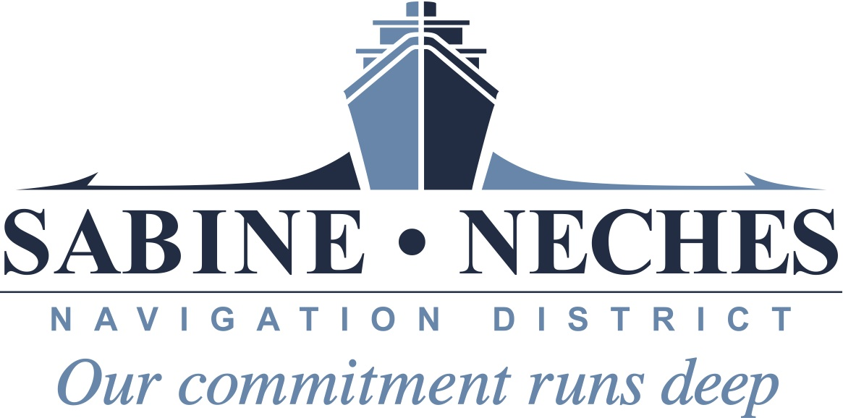

Special Meeting Agenda

The Board of Commissioners of Sabine-Neches Navigation District will meet in public (open) session on May 18, 2022 @ 10:00 a.m. at the Sabine-Neches Navigation 8180 Anchor Drive, Port Arthur, Texas 77642.

In accordance with the policies and orders of the Board of Commissioners, notice of this meeting is posted in accordance with the terms and provisions of Section 551.001 Et. Seq. of the Texas Government Code and all terms and provisions of Section 551.01 are fully and correctly complied with and the 72-hour notice of meeting that is required is being properly and correctly given. Commissioners reserve the right to retire into Executive Session concerning any of the agenda items whenever it is considered necessary and legally justified pursuant to Texas Government Code 551.

AGENDA

- Establishment of a Quorum.

- Consider and take appropriate action concerning Order Canvassing Special Election Return.

- Discuss and take appropriate action on Termination of Spoil Deposit Easement recorded in the Official Public Records of Real Property File Number 381655 of Orange County, Texas and to offer same for repurchase to Optimus Steel LLC, as successor to Gerdau Ameristeel US, Inc. pursuant to Tex. Prop. Code Subchapter E Section 21.101, et. seq.

4. Adjourn Meeting.

Randall Reese, CEO
Sabine-Neches Navigation District
Posted: 5/13/22 @ 9:00 a.m.

